1. Download and install the Arduino editor yourself and configure it into ESP32 development mode, then select the board configuration.
2. 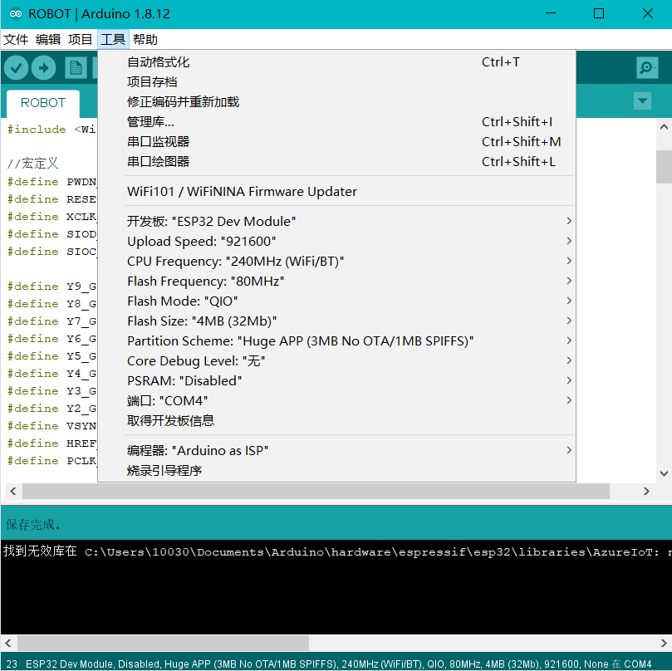
3. Query the local IP address of your computer (the computer running the python program).
4. 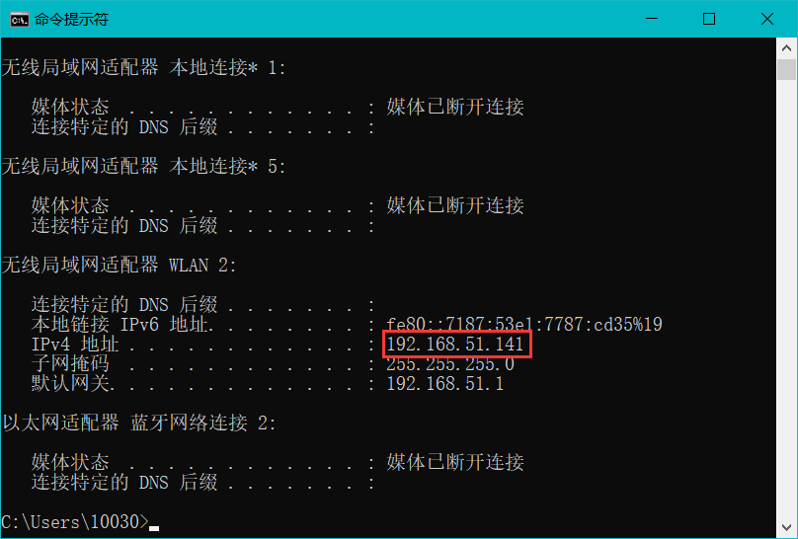
5. Change the IP address to the one you just queried, then change your WIFI name and password (the same as the computer), and then download the program to the robot.
6. 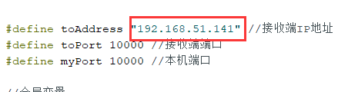

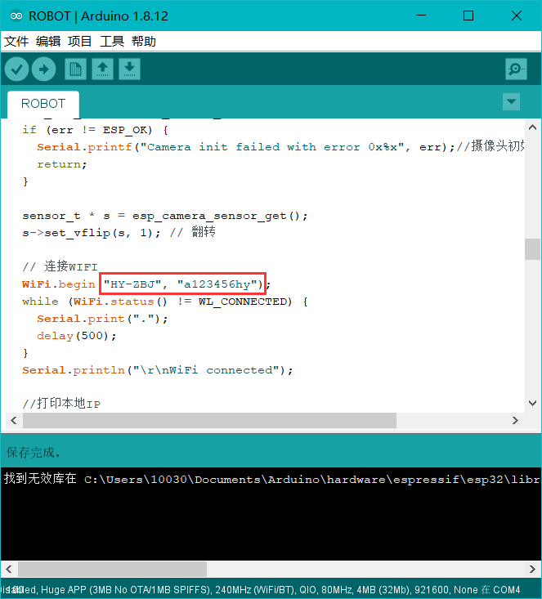

1. Run the camera.py file with Python3.7, and then start the robot.
2. 